T**Project “Infernal Dragons” 1.5-Page GDD**

*Demi Dragons reign terror on earth*

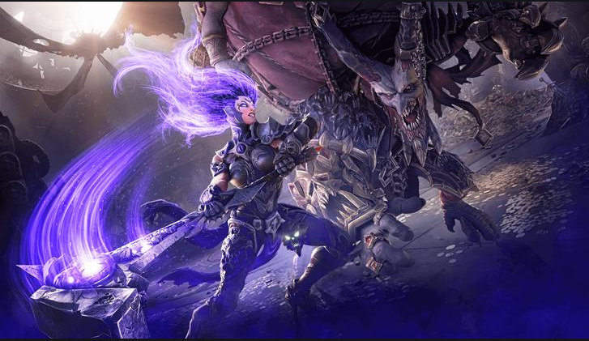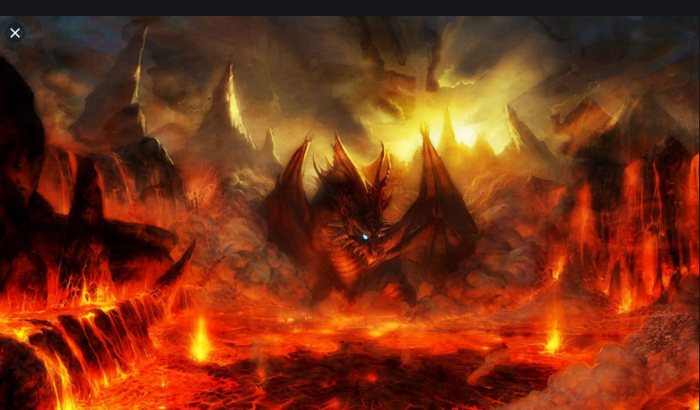

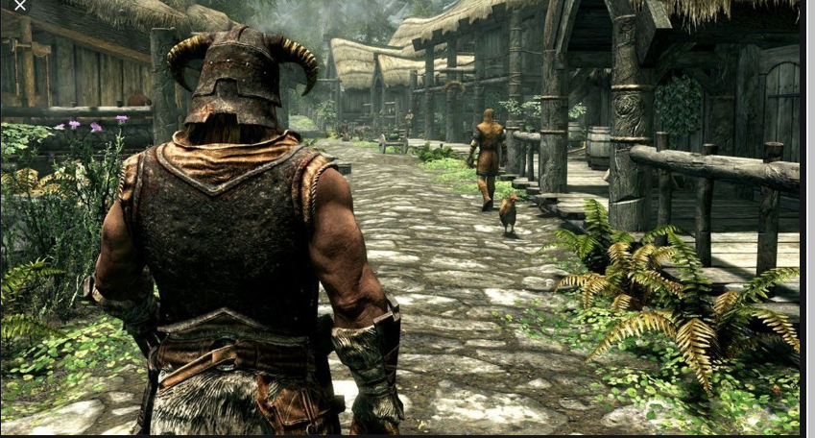

**Genre:** Fixed-camera, Single Player, 3rd-Person Action RPG  
**Target Audience:** 15 yrs+ fans of old school RPGs like Diablo, Skyrim, Devil May Cry, DarkSiders. People who like Action and Adventure.. Rated T for Teens.

**Controls:** Mouse and keyboard

**Thematic Setting:** Medieval Europe, Fantasy, Knights, Swords, Dragons, Magic, Demons

**Tech Stack:** Unity 2019.2, Audacity, Asset Store for 3D and UI

**Platform(s):** Steam

**MVP Game Moment:** 2 minutes of simple linear level flow with basic combat with 3 or 4 enemy types.

**Game Summary:** The Story begins in medieval days where a select few humans discovered their super powers. The hero player hears of the legends which is only a myth, he pursues his quest to attain it and eventually discovers it. Upon discovering it he also realizes far beyond his land there is an evil growing and slowly destroying the lands. The player is then set on a path to destroy it before it takes over. The player ventures the vast lands, discovering all sorts of different tribes with their own unique powers, fighting foes and undertaking quests to increase his power, to gain enough strength to stop the demonic power .

Also, later in a future series this ancient power is awoken and wreaks havoc in a future point in time.

**Core Player Experience:** Adventurer, Powerful, Heroic

**Central Story Theme:** Save the world

**Design Pillar:** Putting the player through difficult challenges, figuring out puzzles in a quest

**Remarkability:** Thrilling adventure, dooming feel

**Anticipated Steam Early Access Launch date:** End of 2020

**Feature Development Priorities:**

* Real-time combat with tons of different enemies to smash
* All the required RPG abilities and stats (upgradeable)
* Level building and game progression
* Branching dialogue system
* Inventory, loot, usable items
* Combat styles: magic, sword, meel
* Lots of cut scenes, cannot skip first time but once watched can skip
* Demi-dragon lord main villain and main hero
* Can have ally pets ranging from: horse, animals, demons

**Reference Games:** Skyrim, Devil May Cry, Darksiders

**Note:**

**Other ideas:**

* Thunder, lightning, dark skies in some scenes
* Maybe- Player chooses his power type when he discovers his powers
* Hero cross path with the ultra demon lord and gets annihilated the first time, the world seems to be coming to an end as he seems too powerful for anyone to handle.
* Contain gore scenes: character limbs can be destroyed when certain body parts are hit with sword enough. Head can explode if hit by a flat weapon or get sliced in two vertically or horizontally when a character is on it’s last life and gets finished off by a head short (similar to Gears Of War).